**Final Project – Pokémon Index**

By Chen Peng (cp3rg)

**Dataset**

This dataset[1] is about the details of different Pokémon (Pokémon Game).

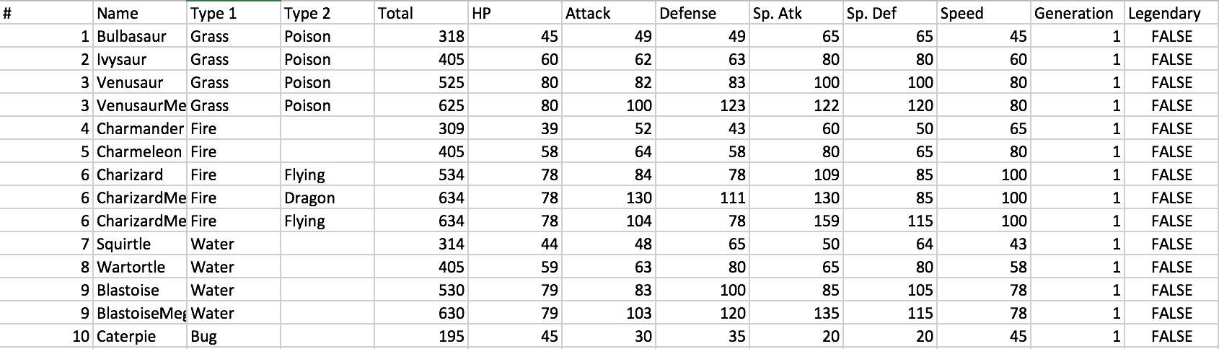

The features are described as bellows.

|  |
| --- |
| #: ID for each pokemon |
| Name: Name of each pokemon |
| Type_1: Each pokemon has a type, this determines weakness/resistance to attacks |
| Type_2: Some pokemon are dual type and have 2 |
| Total: sum of all stats that come after this, a general guide to how strong a pokemon is |
| HP: hit points, or health, defines how much damage a pokemon can withstand before fainting |
| Attack: the base modifier for normal attacks (eg. Scratch, Punch) |
| Defense: the base damage resistance against normal attacks |
| SP_Atk: special attack, the base modifier for special attacks (e.g. fire blast, bubble beam) |
| SP_Def: the base damage resistance against special attacks |
| Speed: determines which pokemon attacks first each round |

There are 721 observations and 13 variables, but not all variables will be used. People used this dataset to discuss what features will most influence the pokemon, but my idea about the data visualization is to represent different skills for different pokemon, so people can clearly know about their pokemon to help them play the game. In other words, it is a Pokémon Pokédex, which is a mini-encyclopedia of Pokémon skills in different fields.

**Data Visualization**

The scatter plot was used to represented the relationship between each variable.

This is the initial page for my project.

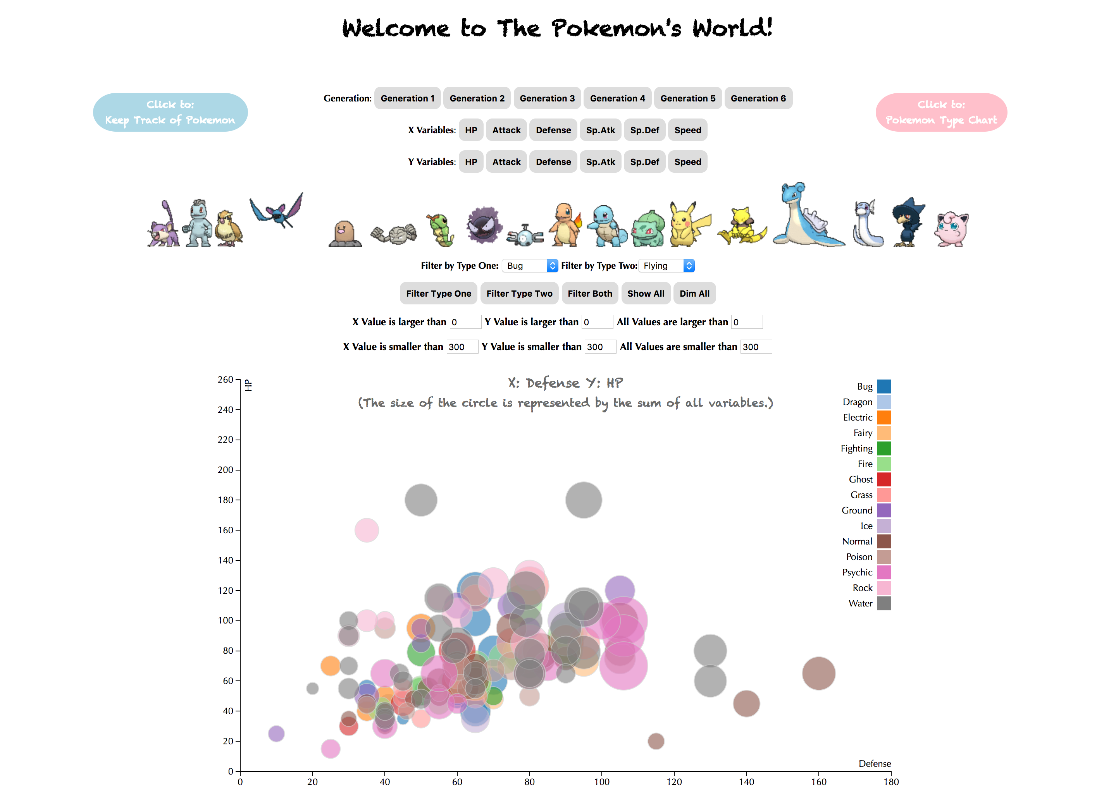

There are some buttons, and let me introduce them.

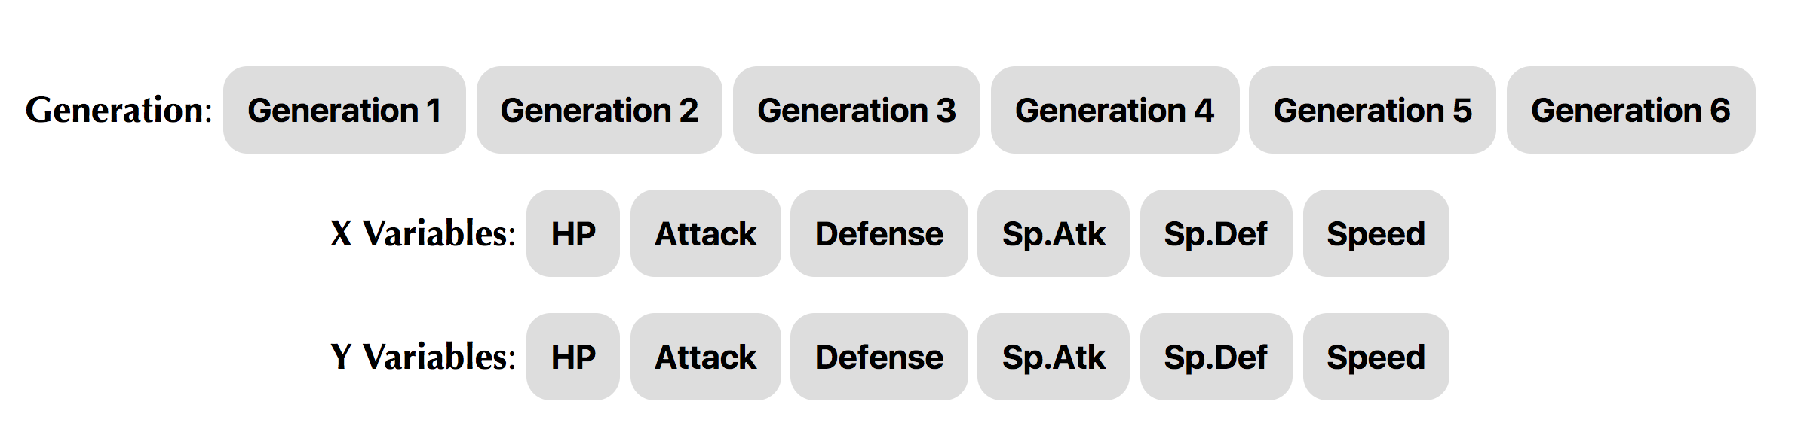

Firstly, since there are six different generations, I added the button to reach different generations. People could click the button to get the different dataset from different generations. Secondly, people can use the X Variables button and Y variables button to change the variable of x-axis and y-axis, so people could explore the variables that they want.

As for the scatter plot, every circle represents one pokemon. The size of the circle was represented by the sum of all variables, and the color was represented by the type one. Thus, if the circle gets closer to the right, the value of X variable is larger, and if the circle gets closer to the top, the value of Y variable is larger.

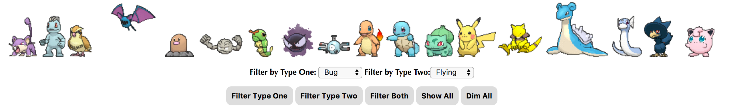

Then, we can come to the types of pokemon. If your mouse is on the gif of different pokemon, you could know about their types. I just choose the classic pokemon to represent their types.

As for the filter button, people could filter the data by type one, type two or the both. People could choose the kind they want and click the button “Filter Type One”, “Filter Type Two” or “Filter Both”, so they can get the conclusion in the scatter plot.

Let us look at an example.

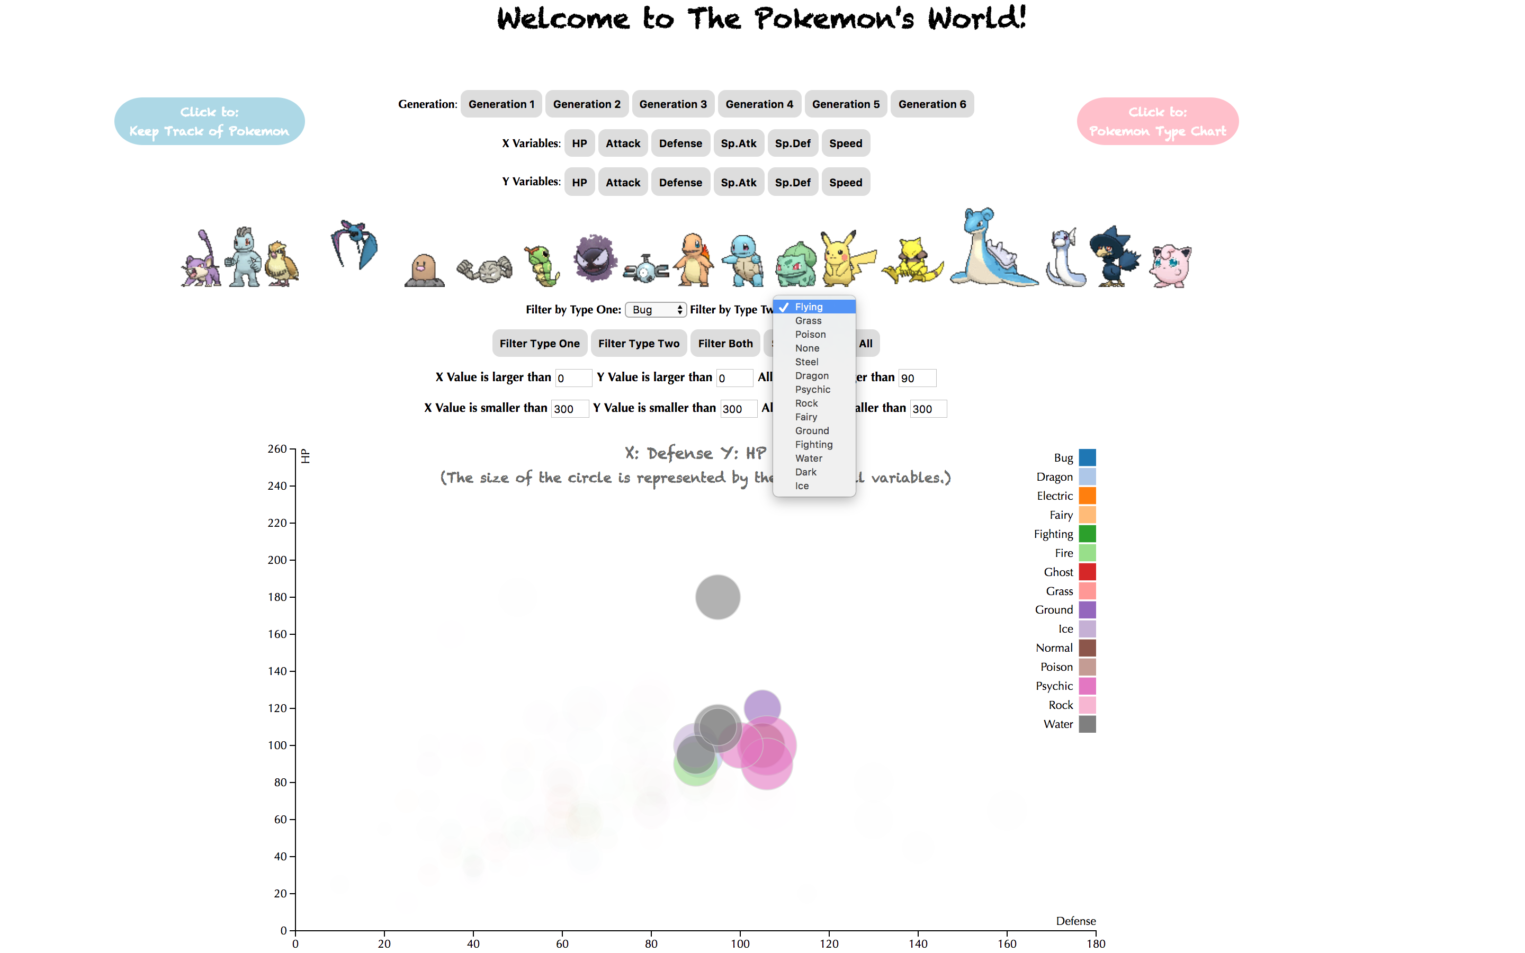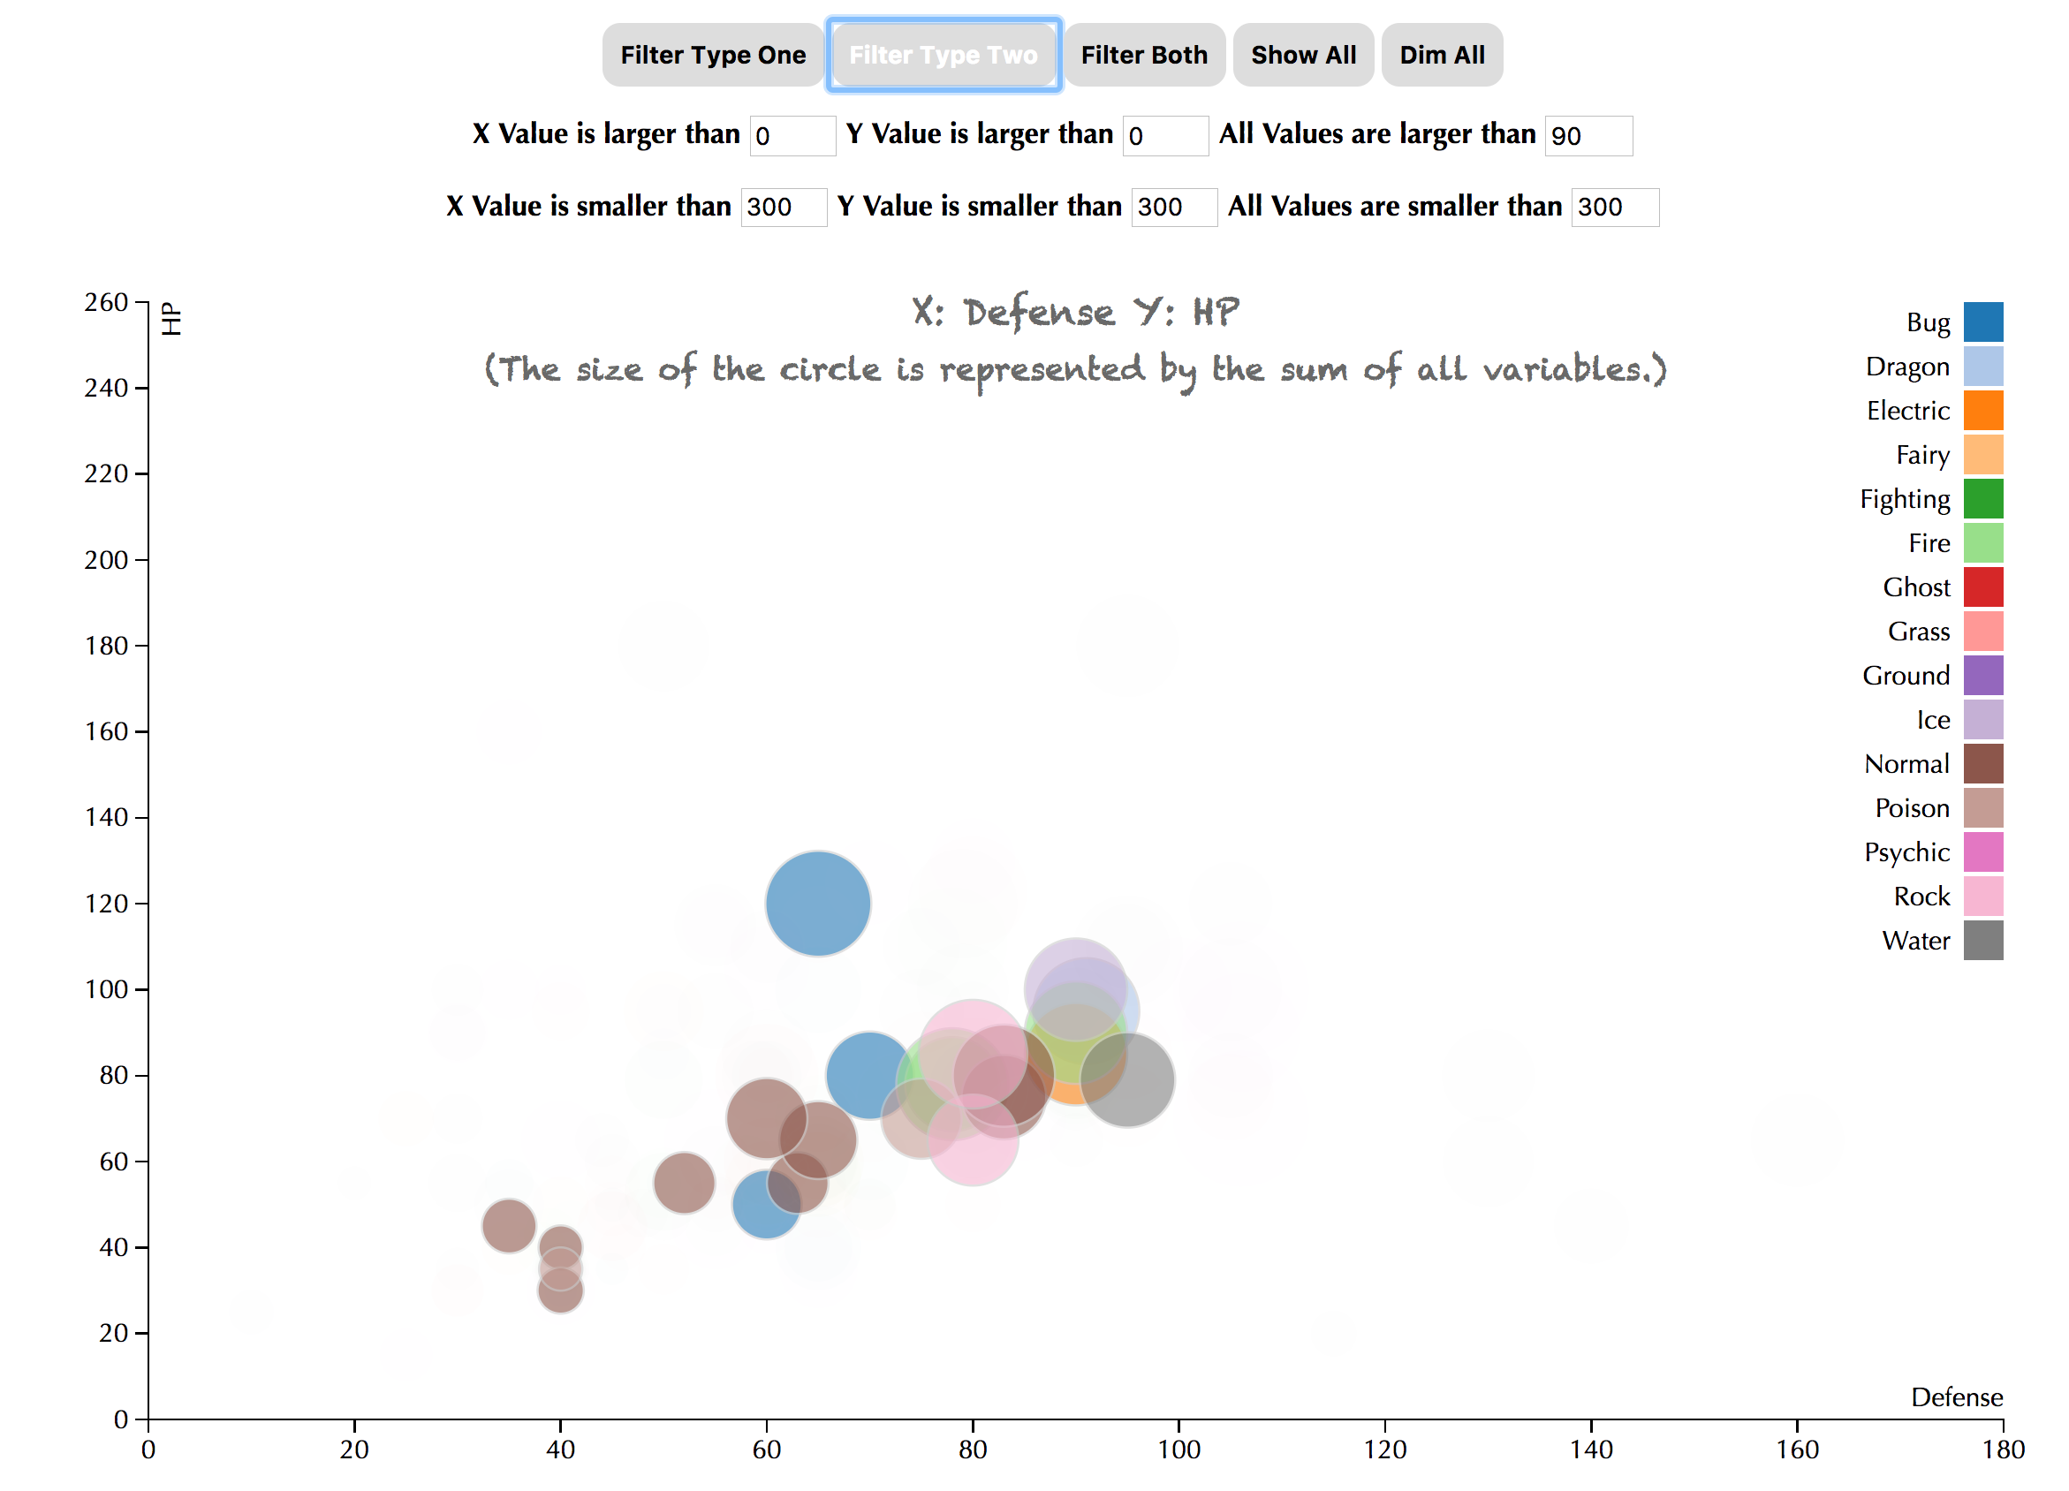

I also added tooltips to help people learn about the circle in the scatterplot, which contains the name, generation, type 1, type 2, the value and the percentage of the pokemon. The percentage is represented by the value divided by the total variable, which will help people to know how important this property is.

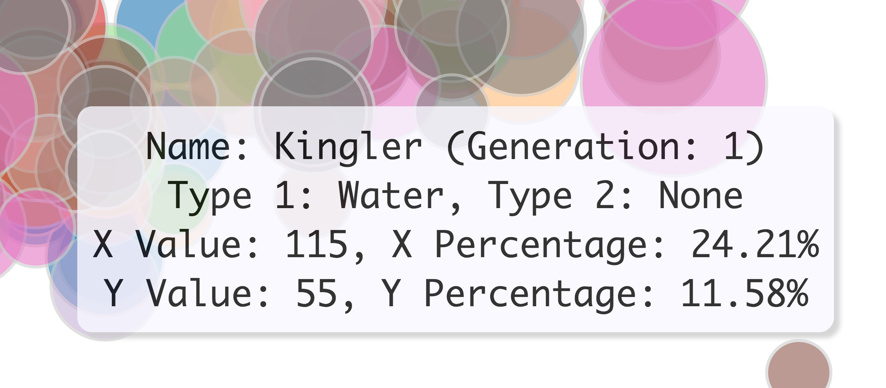

Furthermore, people could use the limit button to limit the range of the value.

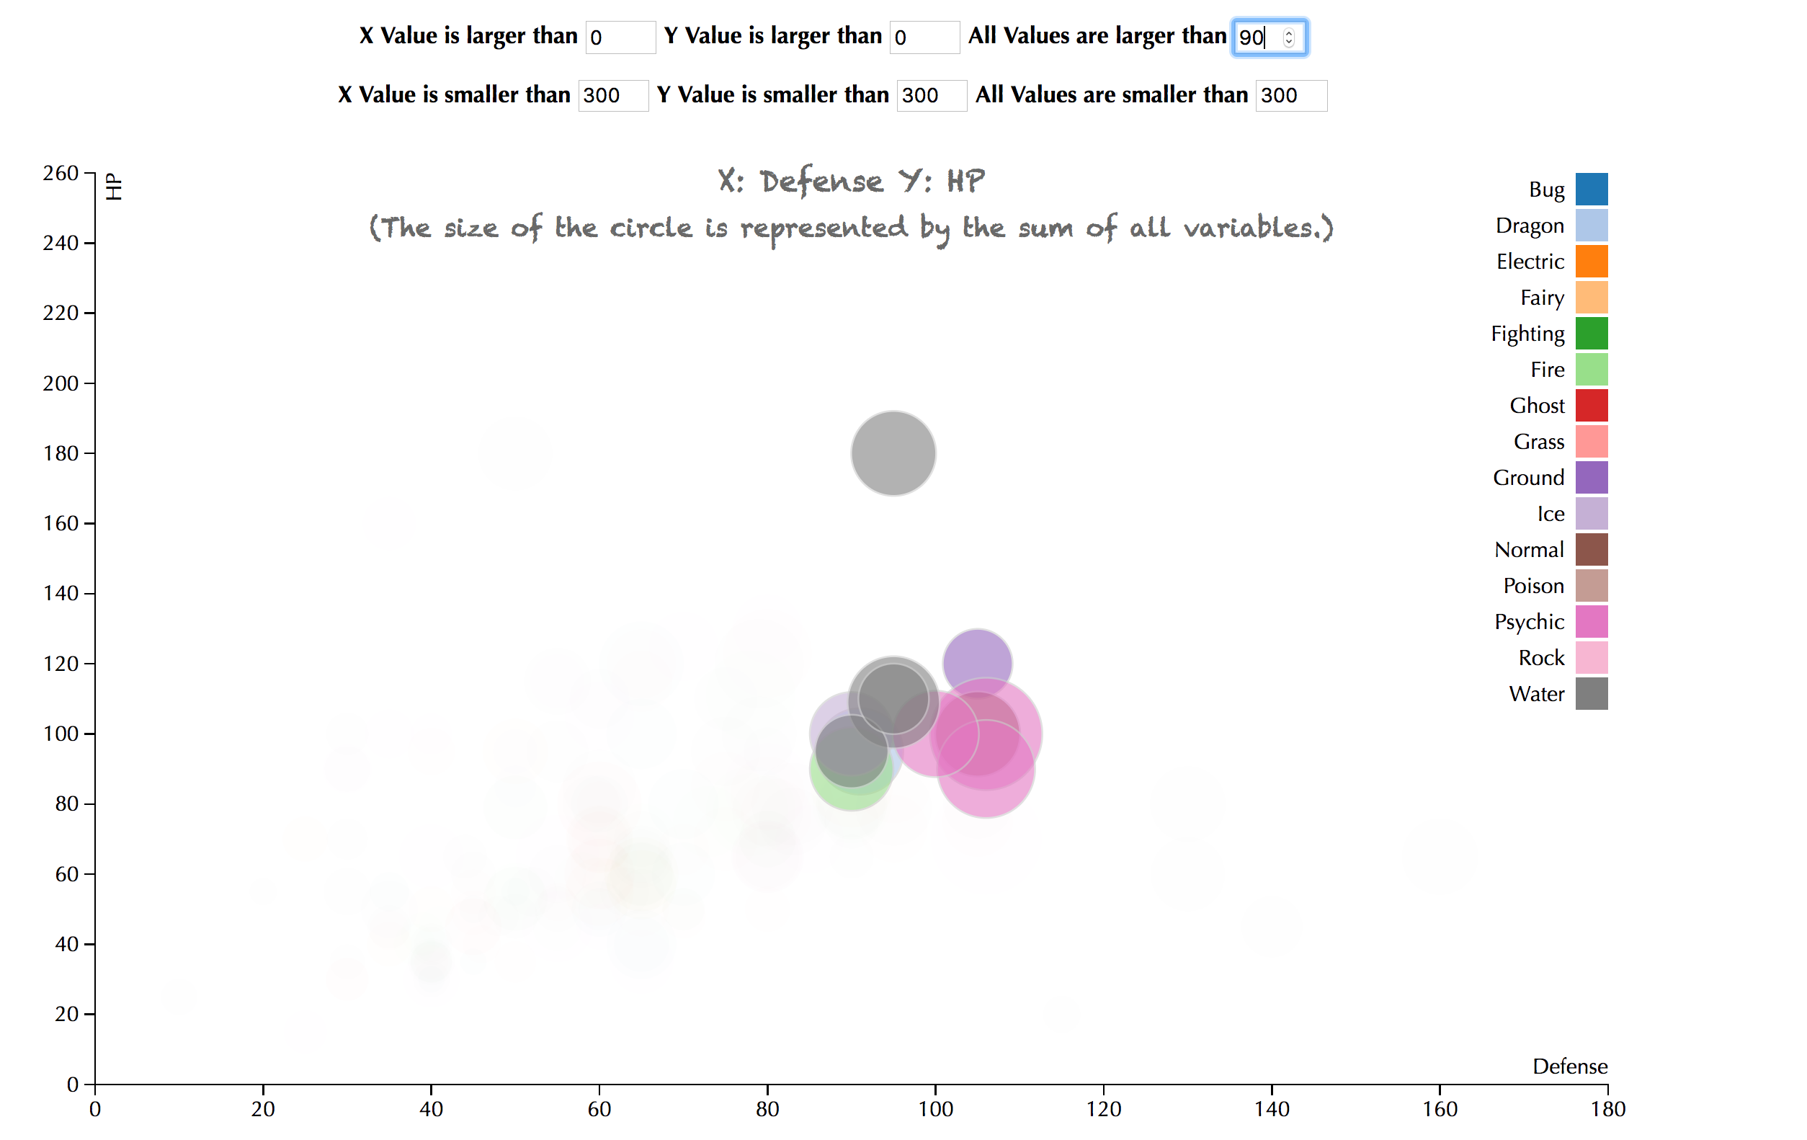

There are six buttons for people to choose. They could find the pokemon whose x value is larger than 100, they could find the pokemon whose y value is smaller than 200, they also could find the pokemon whose both values are larger than 100, and they could input any numbers they want.

Finally, I also added the button to reach two websites. One is the type chart, and the other one is to help people use the name to locate the specific pokemon.

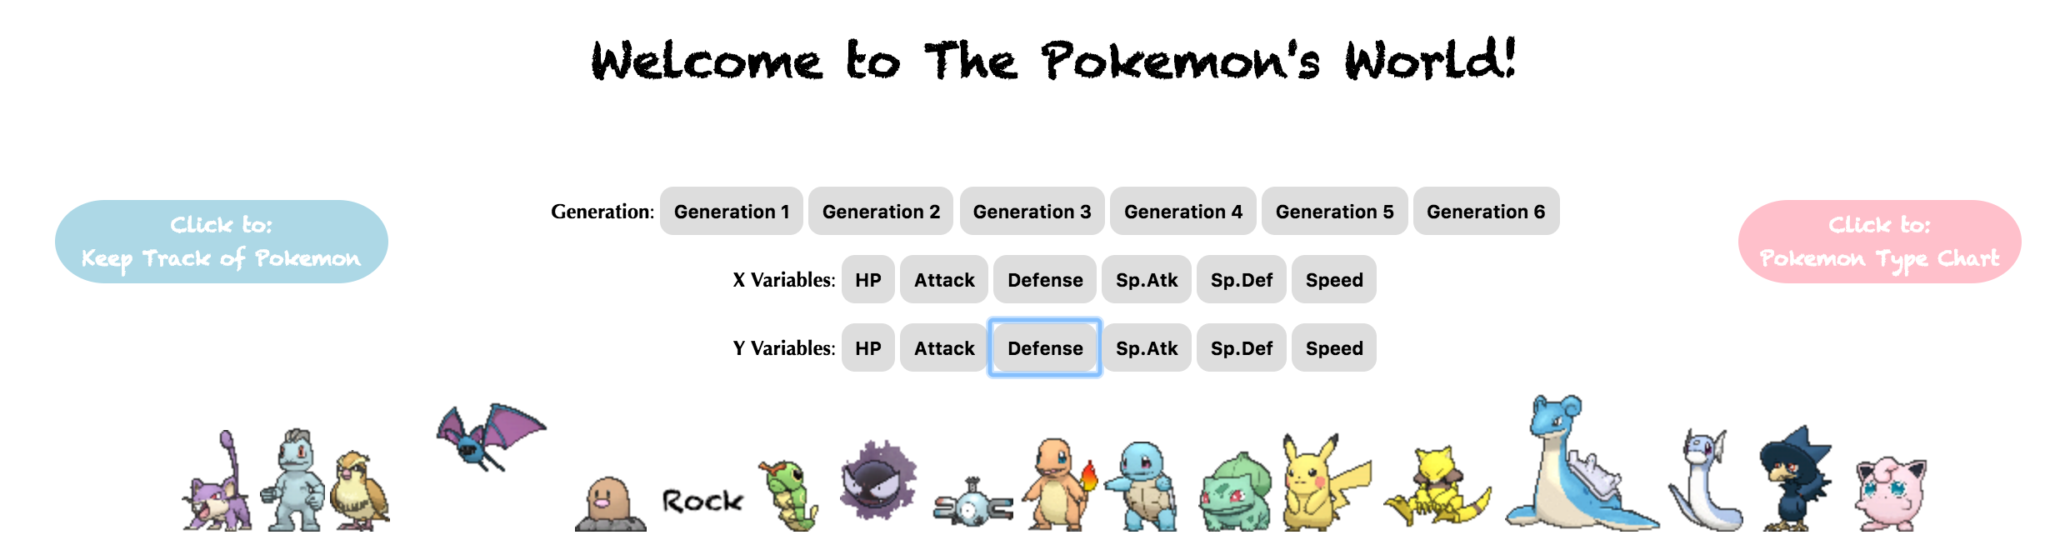

**Discussion**

We can explore the relationship between two variables, so people could use it to decide what pokemon they want to choose. On the one hand, they could use different variables to decide the pokemon. On the other hand, they also can choose pokemon by types.

For example, when people need to fight with someone else, and they will choose several pokemon they have. They will consider about different properties of the pokemon, such as HP, Attack, Defense, and types. Thus, they can use the index to find the most appropriate pokemon for themselves. If the person focuses on attack, but he also cares about the defense, so he could choose X and Y variables to attack and defense, and limit both values to 100. He could get the plot like this in generation 1.

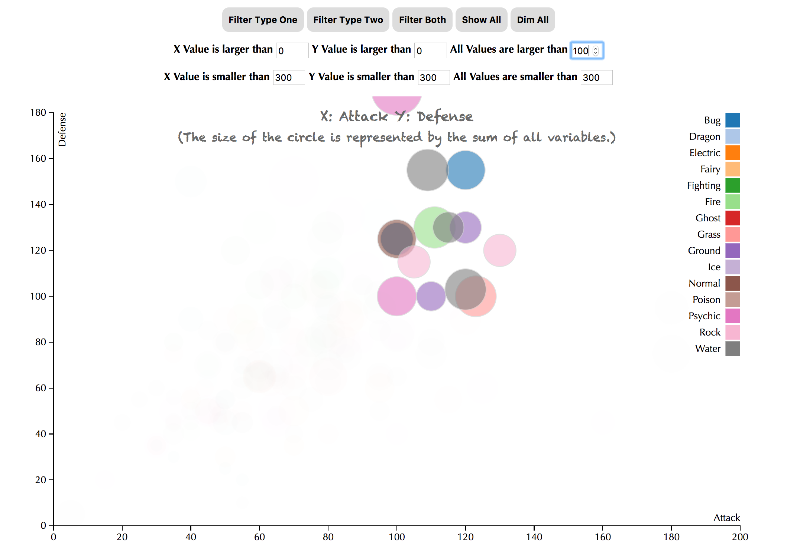

There are different types here, so he can click to the type chart and decide which types he would like to choose. Finally, he could choose several pokemon in this plot. In case, if he can’t remember what the pokemon is, he also could click to keep track of pokemon using their names.

I also find some patterns for this dataset.

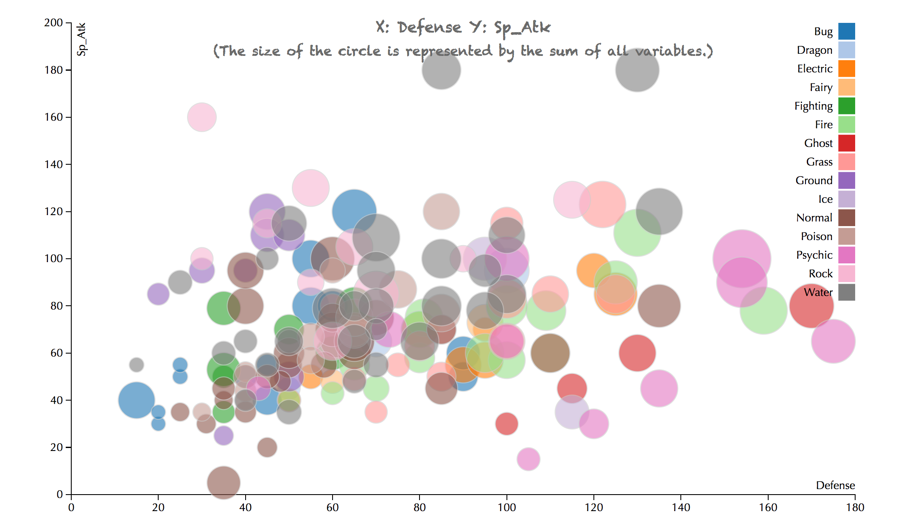

This is the generation one. As we can see, the pokemon whose type one is ghost have a high defense, so people could choose them if people focus on defense.

Besides, we couldn’t only judge a type of pokemon by only one or two properties, since there is no absolute evidence to decide the types of pokemon.

However, it will be better if some parts of it could be improved. Firstly, people could only compare two variables here, which is a little inconvenient, so in the future, I will consider about making a plot to contain all the properties the pokemon have. Furthermore, if I can accomplish zooming in on the picture, it will be clearer for people to observe.

In conclusion, if people want to win a pokemon game, they firstly need to have enough pokemon, and then, they need to design a good strategy to let their pokemon play their strengths. Besides, the evolution of pokemon is also a good way to improve your pokemon.

1. https://www.kaggle.com/abcsds/pokemon